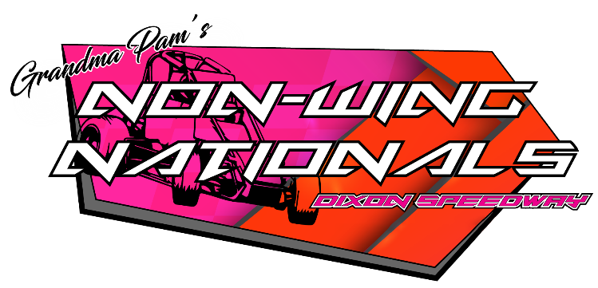

SCCT 5 Heat Format

Qualifying

- Qualifying will consist of two consecutive timed laps unless otherwise noted. Changes to the two-lap qualifying procedure will be at the discretion of officials.
- Qualifying will take place in the order of the pill draw in five groups.
- Drivers will only be attempting to out qualify cars that will be in their hot lap group and subsequent heat race.
- Once a car is pushed off for qualifying, even if it does not start, that is considered an attempt to qualify.
- In the event of two or more cars post the same time in time trials, the tie breaker will be the fastest other lap time of the two consecutive laps recorded. If this does not break the tie, the tie will be broken by the pill draw.

Heat Races – 10 laps

- Heat races will line straight up by qualifying time with the fastest qualifier in each group starting 4th (top four invert).
- Top 4 finishers will advance to the “A” Feature Event; 5th and 6th place finishers advance to the “B” Feature Event, all other finishers to two C” Feature Events.
- Heat race winner and fastest qualifier who finishes 2nd through 4th in each heat race advance to the Dash.

Dash – 10 Cars, 6 laps

- Dash draw line up – 5 heat race winners by overall qualifying time and fastest qualifiers who transferred from their respective heat races to the “A” Feature by overall qualifying time (5).
- A redraw pill of 0, 4, 6, 8 or 10 will be pulled for the dash.
- The finish of the Dash will set the first 10 positions of the “A” Feature Event.

Non-Dash Qualifiers

Heat race “A” Feature transfer cars not eligible for the dash are lined up behind the dash cars by heat race finish (starting position amongst the same place finishing cars will be determined by overall qualifying time) – 2nd place finishers, 3rd place finishers and 4th place finishers.

“B” Feature – 15 laps

“B” Feature cars are lined up by heat race finish (starting position amongst the same place finishing cars will be determined by overall qualifying time) – 5th place finishers and 6th place finishers. Top finishers of the “B” Feature will transfer into the “A” Feature to bring “A” Feature to 24 cars.

“C” Features – 12 laps

Cars are lined up by heat race finish (starting position amongst the same place finishing cars will be determined by overall qualifying time) – 7th place finishers, 8th place finishers, etc. Two “C” Features are then lined up with the inside cars in “C” Feature #1 and the outside cars in “C” Feature #2. Top two finishers from each “C” Feature will tag the rear of the “B” Feature. “C” Feature #1 cars on the inside by finish position and “C” Feature #2 cars on the outside by finish position.

Posted 5/24/22

